5.95: a) The same analysis as in Problem 5.90 applies, but with the speed v an unknown. The equations of motion become
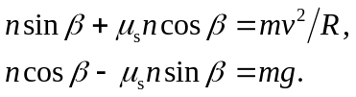
Dividing to cancel n gives
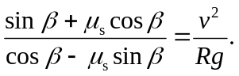
Solving for v and substituting numerical values gives 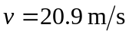 (note that the value for the coefficient of static friction must be used).
b) The same analysis applies, but the friction force must be directed up the bank; this has the same algebraic effect as replacing  with 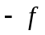, or replacing 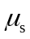 with 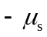 (although coefficients of friction may certainly never be negative). The result is
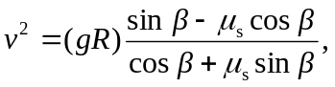
and substitution of numerical values gives 